## Responsive Web Design Principles: Make an Image Responsive

Making images responsive with CSS is actually very simple. Instead of applying an absolute width to an element:

img { width: 720px; }

You can use:

<style>

img {

max-width: 100%;

display: block;

height: auto;

}

</style>

The max-width property of 100% scales the image to fit the width of its container, but the image won't stretch wider than its original width. Setting the display property to block changes the image from an inline element (its default), to a block element on its own line. The height

property of auto keeps the original aspect ratio of the image.

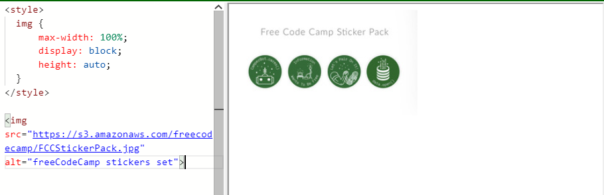

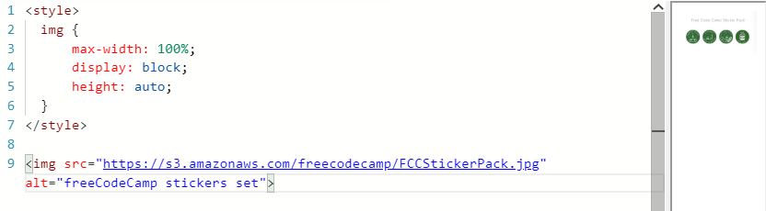

If we set width: 100%; then image will always cover 100% screen space stretching itself out of its original width.

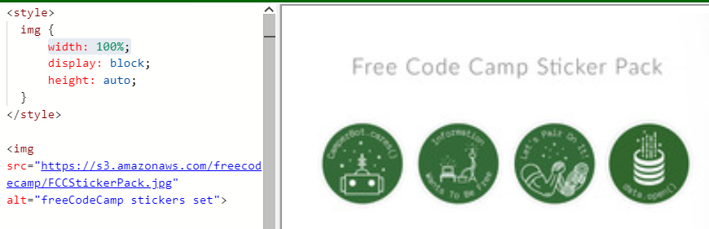

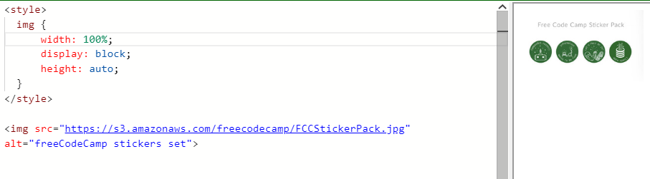

## Responsive Web Design Principles: Make Typography Responsive

Instead of using emor pxto size text, you can use viewport units for responsive typography. Viewport units, like percentages, are relative units, but they are based off different items. Viewport units are relative to the viewport dimensions (width or height) of a device, and percentages are relative to the size of the parent container element.

The four different viewport units are:

|  |  |
| --- | --- |
| vw | 10vw would be 10% of the viewport's width. |
| vh | 3vh would be 3% of the viewport's height. |
| vmin | 70vmin would be 70% of the viewport's smaller dimension (height vs. width). |
| vmax | 100vmax would be 100% of the viewport's bigger dimension (height vs. width). |

Set the widthof the h2tag to 80% of the viewport's width and the widthof the paragraph as 75% of the viewport's smaller dimension.

h2{

width: 80vh;

}

p{

width: 75vmin;

}